Entry Instructions
Important Reminders
The Lafayette County Fair entry process opens Sunday, May 1st and closes Wednesday, June 1st. Please start this process sooner rather than later since it is new to everyone.

Steps

- Go to lafayettecountyfair.fairentry.com to begin the entry process.

- If you have a 4H Online account, you may use that login and skip the next steps. Proceed to the Exhibitor Information section of this document.

If you are an FFA member or need to setup an account, follow the steps below.

- If you need to setup an account, click on the link to create a FairEntry Account. (After that, if you are logging back in, enter the email & password that you created and click the Sign in link.)  - Enter your email address twice and click Create Account. IMPORTANT: This must be a valid email address, so that you can receive the necessary confirmation messages.  - On the Account Creation page, the information requested (all fields are required): Account Name, Phone, Password (enter twice to confirm). Click Create Account. | 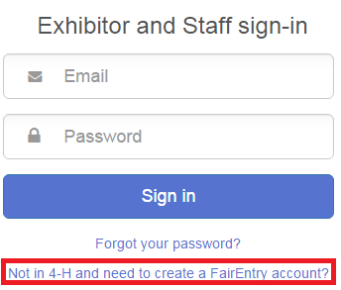

- Click “Begin Registration” | 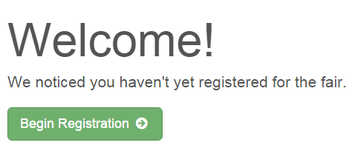
Exhibitor Information

- Enter the information into the four fields—all fields are required. Click Continue when all information is entered. | 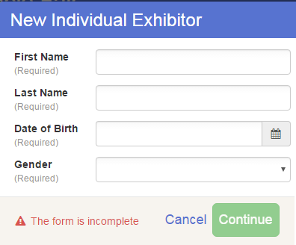
- (If you entered/spelled something incorrectly on the previous screen, you have the option to Delete this Exhibitor on this screen.) Enter the information on the Contact Info screen—the only required field is the top Home Phone Number. You can use the same email address that you used to create the account, or an alternate one. Click Continue when you are finished entering data. | 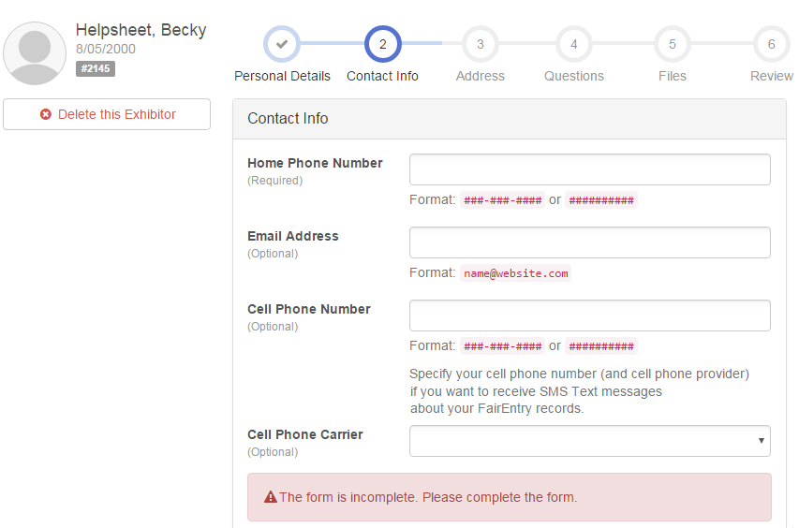

- Enter your mailing address. All fields, except Address continued, are required. As the on-screen help states, the address entered here will be used for mailing premium checks, etc. Click Continue when all information is entered correctly.  - There will be a custom field/question for you to answer asking if you are an open or junior exhibitor. That will be step 4 on the progress bar at the top. This will process your exhibitor fee. | 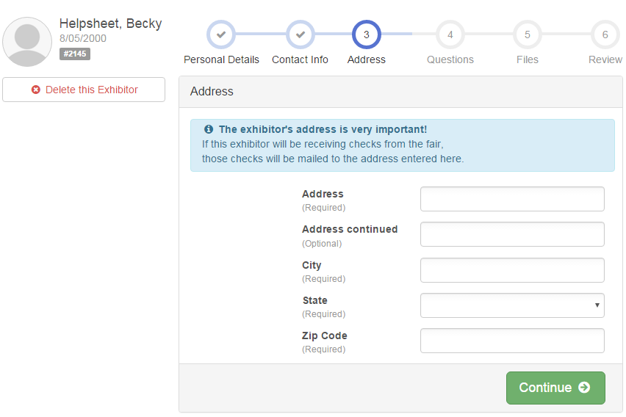
- Review your exhibitor information. If any information is incorrect, click the green Edit button in the appropriate group to change it. When all information is correct, click Continue to Entries. | 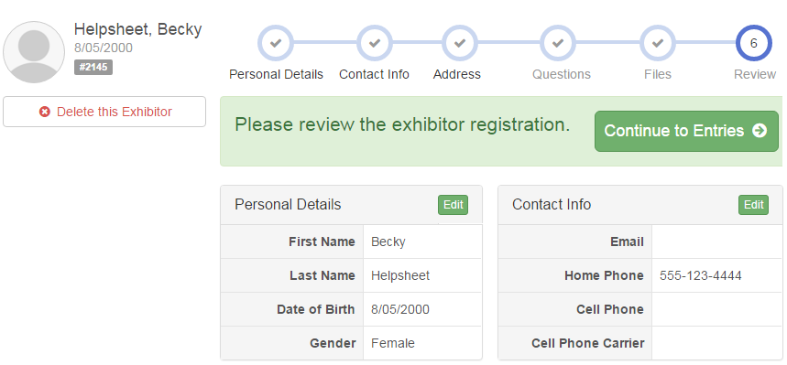

Creating Entries

- Click Add an Entry beside the correct exhibitor (if more than one has been created for each family member).

- Click Select beside the first department you wish to enter. If you need a fairbook, you can pick a hard copy up at the fair office or download an electronic copy on the website at www.lafayettecountyfair.org.

- After you select a department, you will see a list of classes to select from, and then a list of available lots. Also notice that there are blue “Change” links in case you mistakenly select an incorrect department, class, or lot.

- After you have selected the lot, click the green Continue button.

- If this is an animal class entry, you may be required to specify which animal will be exhibited in this class. This is new for 2016.

- Fill in all of the fields with information about the animal you intend to exhibit.

- If the animal information was entered incorrectly, you have the option to either Remove From Entry or Edit Animal Details. When it’s correct, click Continue.

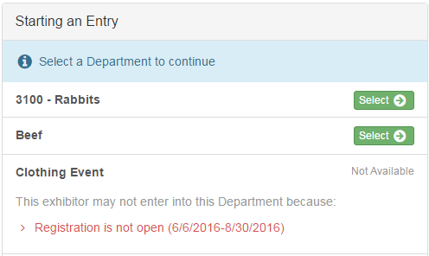
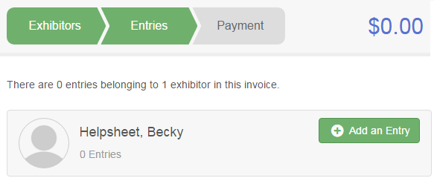
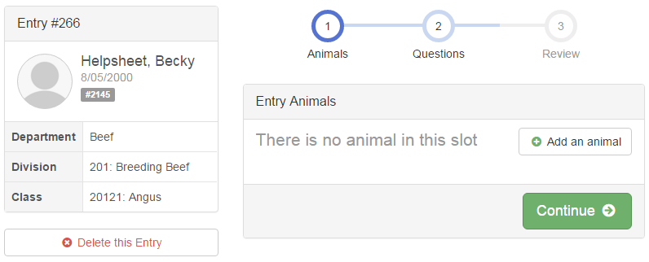
- The Review screen allows you to double check this entry for accuracy, and make any changes necessary. When the information is correct, click Continue and that class entry is complete.

- When each entry is complete, you have three choices for what to do next:  - If all class entries have been completed for one exhibitor, you can Register another Exhibitor in this family.  - If this exhibitor has more entries to make, you can Add another Entry for this Exhibitor.  - If all entries for all exhibitors in the family have been completed, Continue to Payment to finalize and submit your entries. | 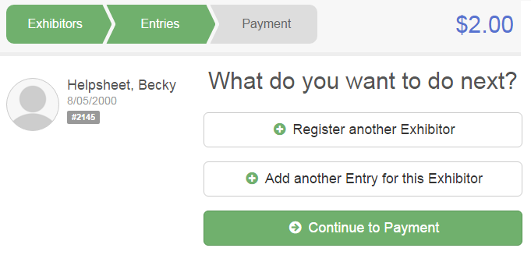
- Review your entries for completeness and accuracy. Notice the Summary and Detail buttons at the top of the list on the right. If there are errors, click on the green Entries section at the top of the page. Click Continue when all information is correct. | 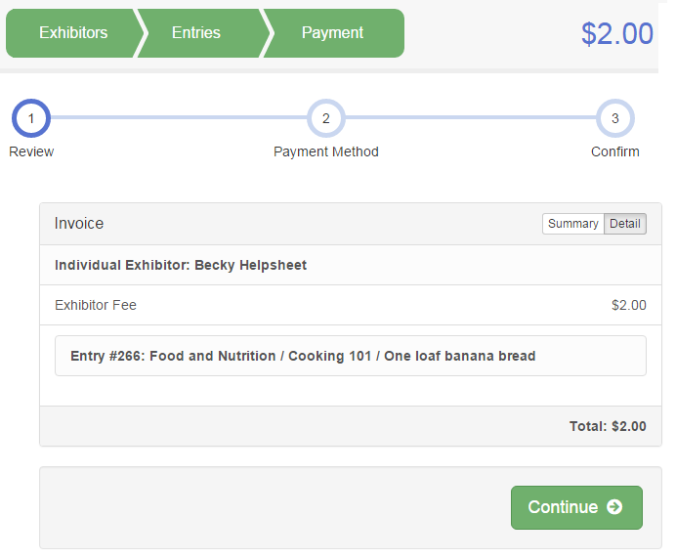

- Read the payment instructions and select check for a method of payment.

- Read the information in the “After you Submit” section. You will also have to check a box to “Agree to Terms”. Click Submit to finalize the entries for the exhibitors in this family. After you click Submit, no changes are possible to these entries.

